AI Content Team for CMS — Setup Guide
Oct 30, 2026 · @Isaac

Overview
The AI Content Team is a group of Claude agents that plans, designs, writes, reviews and mocks up website pages, then saves them as unpublished drafts in the CMS. People always publish. It works today with Storyblok and is built so another CMS can be added later.
- What it does: updates existing pages, creates new ones from the site's existing components, edits the menu and footer where allowed, and shows an HTML mock-up before anything is saved.
- Who it is for: development and content teams that run a headless-CMS website. Each team keeps its own sites' knowledge; the team of agents is shared.
- Where it lives: one public GitHub repository, tayisaac/ai-content-cms, which is also a Claude plugin marketplace called aicontentteam. The plugin inside it is content-team.
- Where it runs: Claude Code (recommended for development teams) or Cowork in the Claude desktop app. Both install the same plugin from the same repository.
- Owner: Isaac Tay (@tayisaac) approves every change to the agents and the safety check. Current version: 0.1.9.

How it works
You talk to one Claude, the Coordinator. It follows a workflow, hands each step to a specialist agent, passes work between them as files in a run folder, and stops for your approval before anything is saved to the CMS.
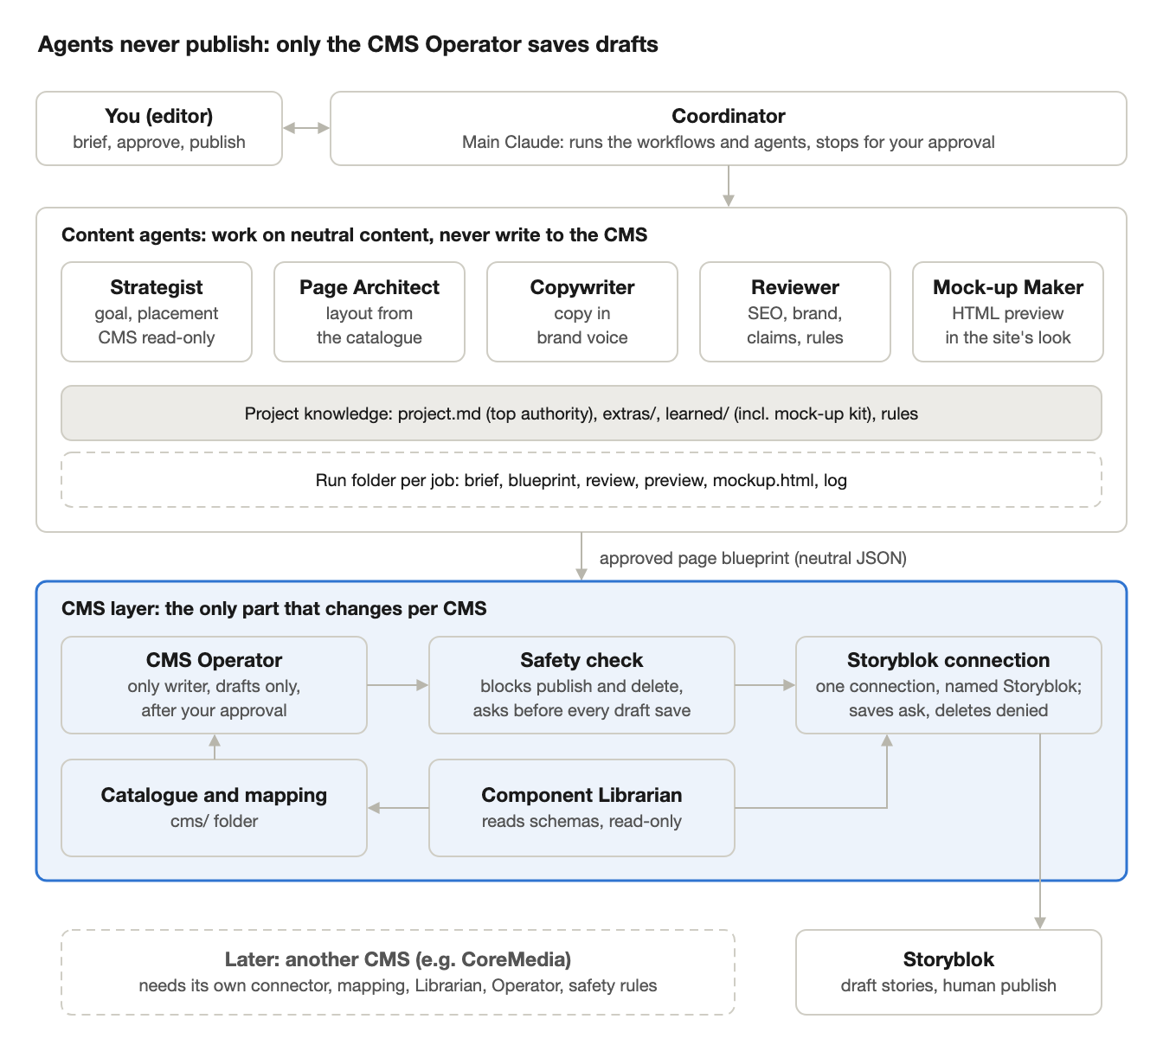
how a job flows · coordinator, agents, knowledge, CMS layer
Only the CMS layer knows about Storyblok; everything above it would stay the same with another CMS.

The agents
Agent | Job | CMS access
Coordinator (main Claude) | Runs the workflow, starts each agent, asks for your approval, builds the mock-up kit with a browser | None directly
Content Strategist | Decides new page or update, goal, audience, key messages, where it sits | Read only
Page Architect | Lays out the page from existing components (the blueprint); flags component gaps | None
Copywriter | Writes the copy in the brand voice, all languages | None
Content Reviewer | Checks structure, facts, claims, voice, SEO, accessibility; PASS or FAIL | None
Page Mock-up Maker | Builds an HTML mock-up of the page in the site's look (before and after for updates) | None
Component Librarian | At setup, reads the CMS and drafts the component catalogue, mapping, content model and page patterns | Read only
CMS Operator | Previews the change field by field, then saves it as a draft after your approval | Read + draft write

How a job runs
Ask in plain words, e.g. "create a page for our dry eye clinic" or "update the About Us page".
- Freshness check: the Coordinator compares project.md with the knowledge files and flags anything out of date.
- Brief: the Strategist writes brief.md.
- Blueprint: the Page Architect writes blueprint.json, using only components in the catalogue.
- Copy: the Copywriter fills every field.
- Review: the Reviewer writes review.md. A FAIL stops the job.
- Preview and mock-up: the CMS Operator writes preview.md; the Mock-up Maker writes mockup.html.
- Your approval: you read the review, preview and mock-up and say "approved" (or ask for changes).
- Draft saved: the CMS Operator saves an unpublished draft tagged ai-draft, reads it back and writes log.md.
- You publish in the CMS when ready.
Every file for a job sits in <project>/runs/<date>-<slug>/, so each change has a record of who approved what.

Guardrails
These are built into the plugin and apply to every team. A team can tighten them in its project.md, but not loosen them.
- Drafts only. A safety check runs before every CMS write. It allows only saving a story as a draft and blocks publishing, unpublishing, scheduling, deleting, image uploads, component or settings changes and AI translation. If it can't read a call, it blocks it. It needs python3 on the machine. Every draft save it allows also shows you a confirmation prompt, whatever the CMS connection is called.
- One writer, after approval. Only the CMS Operator can write, only after you say "approved", and Claude also asks you to allow the call itself.
- Existing components only. Agents build pages from the component catalogue. Missing components are flagged as gaps for developers.
- project.md is the top authority. It says where agents may create, what they may only edit, and what they must never touch. Agents never edit it.
- Menus and footers are edit-only where allowed: links may be added or changed, never deleted or reordered without asking.
- Tagging. Every story agents create or edit gets the ai-draft tag; existing tags are kept.
- One CMS connection. In Claude Code, Storyblok is connected only through the workspace's .mcp.json (server name Storyblok). If its tools show up under another name, such as a connector named by an ID, the agents won't use them and the job stops until the connection is fixed. The workspace's ask and deny rules use wildcards (mcp__*__…), so they cover the CMS under any name.
- No invented facts. Mock names or copy only when asked, marked [TODO]; claims and prices are flagged for a human when no approved claims list exists.

What lives where
The team (agents, skills, safety check) lives in one shared repository. Each development team keeps its own workspace with its sites' knowledge. Teams never copy the agents.
1. The shared repository (owner only), tayisaac/ai-content-cms:
.claude-plugin/marketplace.json the catalogue Claude reads (marketplace "aicontentteam")
plugins/content-team/ THE TEAM: edit here to change behaviour
.claude-plugin/plugin.json version number (bump on every release)
agents/ one file per agent
skills/ workflows + content-team-rules (rules, defaults, formats)
hooks/ the safety check
workspace-template/ what each team copies to start its workspace
docs/ onboarding, maintaining, enforcing guardrails
scripts/validate.py release checks (run on every pull request)
scripts/build-cowork-plugin.sh optional .plugin file for upload-only installs
CHANGELOG.md one entry per release
2. A team workspace (one per development team, its own repository):
CLAUDE.md tells Claude this workspace uses the content-team plugin
.mcp.json CMS connection (server name "Storyblok")
.claude/settings.json registers the marketplace, enables the plugin, CMS permissions
_template/ _example/ starting point for new projects
<Project>/ one folder per website
3. A project folder (one per website, inside a workspace):
File or folder | Holds | Written by
project.md | Site URL, CMS permissions, voice, must-follow rules, approvers | The team (about one page)
extras/ | Brand guide, claims list, SEO checklist | The team, optional
learned/ | Content model, page patterns, voice and site notes, mock-up kit | Agents draft, team reviews
cms/ | Component catalogue and CMS mapping | Agents draft, team reviews with a developer
runs/ | One folder per job: brief, blueprint, review, preview, mock-up, log | Agents

For the owner: updating the team
A merged pull request with a higher version number is a release. There is no build step: the GitHub repository is the marketplace, and every team's Claude reads it from there.
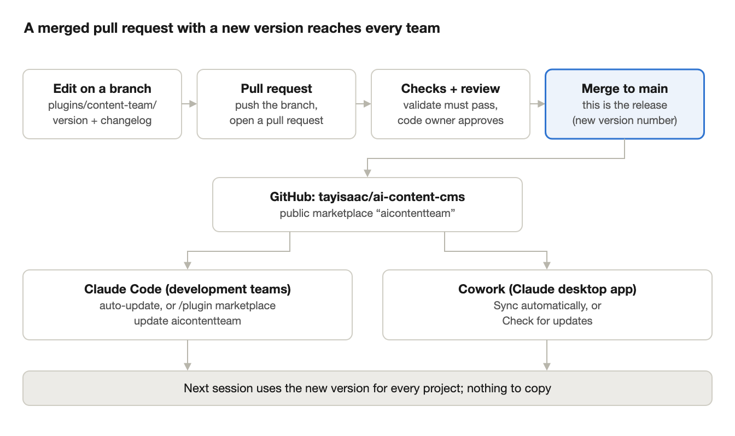
release flow · 4 steps, then every team updates
If the version number doesn't change, teams keep their current copy even after the merge.

Release a change
Work in your clone, ~/Projects/ai-content-cms. Never edit Claude's installed copy under ~/.claude/plugins/, a team workspace, or the old ContentTeam-ClaudeCode folder.
- Start from the latest: git checkout main, git pull, then git checkout -b <short-name>.
- Make the change in plugins/content-team/ (see the table below). You can also open Claude Code in the repository and ask for the change in plain words.
- Bump the version in plugins/content-team/.claude-plugin/plugin.json (e.g. 0.1.7 to 0.1.8). Without a bump, nobody receives the change.
- Add a changelog entry at the top of CHANGELOG.md: ## content-team 0.1.8 (date) plus one line per change.
- Check it: python3 scripts/validate.py. It also tests the safety check against 12 cases and checks the workspace permission rules.
- Try it in a test workspace (not a real project): turn off the installed content-team in /plugin, run claude --plugin-dir ~/Projects/ai-content-cms/plugins/content-team, do one read-only job and check that publishing is still blocked.
- Push and open a pull request: git push -u origin <short-name>, then open the pull request on GitHub.
- Merge when the "validate" check is green. As repository admin you can merge your own pull request; anyone else's needs your approval.
- Tag it (optional): git checkout main && git pull && git tag content-team--v0.1.8 && git push --tags.
- Tell the teams: the new version and its changelog entry. Say clearly if they need to do anything (for example a new field in project.md).

Where to make each change
To change | Edit
An agent's instructions or allowed tools | plugins/content-team/agents/<agent>.md
A workflow (create, update, set up, mock-up kit, refresh) | plugins/content-team/skills/<workflow>/SKILL.md
Shared rules, defaults, file formats | plugins/content-team/skills/content-team-rules/
The safety check | plugins/content-team/hooks/guard-cms-writes.py and hooks.json
Version | plugins/content-team/.claude-plugin/plugin.json
What new teams start with | workspace-template/
Version guide: patch (0.1.x) for wording and fixes, minor (0.x.0) for new agents, skills or workflow steps, major for changes teams must act on.

How the repository is protected
- The repository is public, so teams install without a GitHub login. Only the owner can change it.
- The "Protect main" rule: no deleting main or force-pushing; changes only through pull requests with 1 approval from the code owner; the "validate" check must pass. The admin may merge their own pull requests (still via a pull request).
- Claude Code sessions in the repository ask before every push and can't force-push, delete a branch on GitHub or delete the repository (.claude/settings.json). CLAUDE.md tells Claude to branch and open a pull request instead of committing on main.
- CODEOWNERS makes the owner the reviewer of everything, the safety check above all.
- Teams that want a change fork the repository and open a pull request, or open an issue.

Optional: lock the guardrails on company machines
IT can deploy Claude Code managed settings (docs/managed-settings.example.json in the repository): it registers the marketplace for everyone, turns on auto-update, enables content-team, allows only this marketplace and denies the CMS delete and upload tools under any server name, whatever a workspace says.

For development teams: setup
About an hour for the team lead once, then about 15 minutes per person. Claude Code is recommended for development teams; Cowork works too.

What you need
- Claude Code (desktop app Code tab or command line), or the Claude desktop app for Cowork
- git and python3 (the safety check needs python3; without it every CMS write is blocked)
- A Storyblok account with access to your space, ideally a role that cannot publish
- A browser tool for mock-ups: Claude in Chrome or a Playwright server (optional)
- A named person who approves and publishes in the CMS

Team lead: create the team workspace (once)
- Create a private repository for your team, e.g. your-org/contentteam-<team>.
- Copy everything in the shared repository's workspace-template/ folder into it, including the hidden .claude/, .mcp.json and .gitignore. Replace [Team name] in its README.
- If your Storyblok MCP server isn't the hosted one, change the URL in .mcp.json. Keep the server name Storyblok: the agents and the workspace permissions use it.
- Commit and push. Teammates clone this repository.

Each person: Claude Code
- Clone the team workspace and open Claude Code in it. Accept the trust prompt; Claude Code registers the aicontentteam marketplace and offers to install content-team. If it doesn't, run /plugin marketplace add tayisaac/ai-content-cms, then /plugin install content-team@aicontentteam.
- Approve the Storyblok server, run /mcp and sign in. On Storyblok's screen choose only your team's spaces, with read and write for stories. If the desktop app's sign-in is refused, sign in once from Terminal: run claude, then /mcp. Use only this server: if you also connected Storyblok in the Claude app or on claude.ai, switch that connector off.
- Turn on auto-update: /plugin → Marketplaces → aicontentteam → Enable auto-update.
- Check: ask "list the subagents and skills available in this session" (seven content-team: agents, six skills), then "try to publish a test story" (it must be blocked by the content-team safety check). Saving a draft must show a confirmation prompt labelled [plugin:content-team].

Each person: Cowork (Claude desktop app)
- Customize → Plugins → Add marketplace, paste https://github.com/tayisaac/ai-content-cms, then install content-team.
- Turn on Sync automatically for the marketplace, or use Check for updates after each release.
- Connect Storyblok in Settings → Connectors: read and write for stories; set publish-type actions to need approval or block them. It must appear as Storyblok; under any other name the workflows stop and ask you to fix it.
- Start a Cowork task with your team workspace folder connected.
A plugin installed in Cowork is saved to your Claude account, so it also appears in Claude Code. If Claude Code then lists content-team twice, keep one and turn the other off in /plugin.

Starting a project and day-to-day use

Start a project (once per website)
- Copy _template/ to a new folder named after the site, e.g. MySite/.
- Fill in MySite/project.md (see _example/project.md). The CMS permissions (where agents may create, what they may only edit, what they never touch), the approvers and the site URL matter most; "unknown" is fine elsewhere.
- Drop existing documents (brand guide, approved claims list, SEO checklist) into MySite/extras/.
- Say "set up the MySite project". The Component Librarian reads the CMS (read-only) and drafts learned/ and cms/.
- Optional: "inspect the site at [URL]" to record how pages really look, and "build the mock-up kit" so mock-ups match the site's styling.
- Review the drafted files (cms/ with a developer) and change Status: draft to Status: reviewed.
- Pilot: a read-only job first ("refresh the component catalogue"), then one small update, then one new page.

What to say
Say | What happens
"Update the [page] page …" | Brief, blueprint changes, copy, review, field-by-field preview, before/after mock-up, your approval, draft saved
"Create a page for …" | The same for a new page built from existing components
"Add [link] to the menu" / "update the footer" | Edit-only changes where project.md allows them
"Build the mock-up kit" | Captures the site's CSS, header, footer and one example per component
"Refresh the component catalogue" | Re-reads components after developer changes and reports what changed
Name the project in each request when a workspace has more than one.

Approving and publishing
- Read review.md, preview.md and mockup.html in the run folder, then reply "approved" or ask for changes. Claude then asks you to allow the CMS call itself, in a prompt labelled [plugin:content-team] that names the page.
- Publish in the CMS yourself. Drafts that depend on each other go live together or in order (e.g. a new page before the menu link to it; the menu and footer together).
- Commit the runs/ folders to your workspace repository: they are the audit trail.
- When your site changes (new port, new permissions, new pages), update project.md. The next job's freshness check flags knowledge files that disagree, and the Librarian can bring them in line.

Staying up to date
With auto-update on, new versions arrive by themselves and apply from the next session (or /reload-plugins). Otherwise run /plugin marketplace update aicontentteam. /plugin → Installed shows the version you have.

Troubleshooting and FAQ
Problem or question | What to do
The content-team agents or skills are missing | Run /plugin and check content-team is installed and enabled; if not, /plugin install content-team@aicontentteam
A new release didn't arrive | The owner must bump the version. Then run /plugin marketplace update aicontentteam and start a new session
Plugin install fails on a machine without a GitHub SSH key | Set CLAUDE_CODE_PLUGIN_PREFER_HTTPS=1 and try again
Storyblok sign-in refused in the desktop app's Code tab | Sign in once from Terminal: claude, then /mcp
"Missing CMS tools" from the Strategist, Librarian or Operator | The CMS server must be named Storyblok in .mcp.json (or the Cowork connector); under any other name the workflows stop and ask you to fix the connection
Every CMS write is blocked, even drafts | python3 isn't installed, or the call included a publish option. Check the message from the content-team safety check
The Storyblok connector from claude.ai also shows up in Claude Code | Its tools have an ID in their names, which can differ per account. Turn it off for Code sessions. The agents won't use it, the workspace's wildcard ask and deny rules cover it, and the safety check asks before each draft save.
content-team appears twice | One copy comes from your Claude account (Cowork), one from the workspace. Keep one, turn the other off in /plugin
The agents refused a change | Usually project.md doesn't allow it (e.g. a "never touch" area). Change project.md first if the change is intended
Knowledge files disagree with project.md | project.md wins. Accept the freshness check's offer to sync, or say "refresh the component catalogue"
Can my team change an agent just for us? | Ask for it to become a project.md setting, or open a pull request. Don't add same-named agent files to your workspace: they override the shared ones and stop receiving updates
Can we use a different CMS? | Not yet. A CMS needs its own connector and changes to the Librarian, CMS Operator, Strategist and safety check; see the CoreMedia doc

Links and sources
- tayisaac/ai-content-cms: the repository, with README, CHANGELOG and the docs/ folder (onboarding a team, maintaining, enforcing guardrails)
- Connecting the Content Team to CoreMedia: what adding a second CMS involves
- Multi-Agent CMS Content Team: original setup guide: design history, the EyeClinic pilot and lessons learned
- Claude Code: host and maintain a plugin marketplace
- Claude Code: marketplace reference
- Claude Code: manage plugins for your organization
- Cowork: install plugins and add a Git repository as a marketplace
- Storyblok MCP server

